**NEPAL COLLEGE OF INFORMATION TECHNOLOGY**

Balkumari, Lalitpur

*Affiliated to Pokhara University*

**LAB REPORT FOR DATABASE MANAGEMENT SYSTEM**



**LAB REPORT 4: FAMILIARIZATION WITH DML COMMANDS (INSERT, UPDATE, DELETE)**

Submitted by: Submitted to:

Name: Arpan Adhikari Er. Simanta Kasaju

Roll No.: 231309

BE-CE (3rd SEM)

|  |  |  |  |
| --- | --- | --- | --- |
| **S. N** | **LAB TOPIC** | **DATE** | **REMARKS** |
| **1.** | **INTRODUCTION TO SQL** | 10th Nov |  |
| **2.** | **FAMILIARIZATION WITH DDL COMMAND** | 17th Nov |  |
| **3.** | **FAMILIARIZATION WITH VARIOUS CONSTRAINTS IN SQL** | 24th Nov |  |
| **4.** | **FAMILIARIZATION WITH DML C­­OMMANDS (INSERT, UPDATE, DELETE)** | 1st Dec |  |
|  |  |  |  |
|  |  |  |  |
|  |  |  |  |
|  |  |  |  |
|  |  |  |  |

**LAB 4: FAMLIARIZATION WITH DML COMMANDS (INSERT, UPDATE, DELETE)**

**OBJECTIVE:**

To gain a thorough understanding and practical experience with Data Manipulation Language (DML) commands, specifically **INSERT**, **UPDATE**, and **DELETE**, which are essential for managing and modifying data in relational database management systems. This includes learning to:

1. Insert new records into database tables using the **INSERT** command.
2. Modify existing data in tables with the **UPDATE** command.
3. Remove unnecessary or incorrect data using the **DELETE** command.
4. Apply these commands effectively in various real-world scenarios to maintain and manipulate database integrity and accuracy.

**THEORY:**

Data Manipulation Language (DML) is an essential subset of SQL, designed for managing and manipulating data within relational databases. It includes commands that allow users to perform operations such as inserting, updating, and deleting records in tables.

Key aspects of DML include:

1. **INSERT Command:**
   * Used to add new data into a table.
   * Specifies the columns to be populated and the corresponding values to insert.
   * Ensures that new records adhere to constraints like primary keys, foreign keys, and data types.
2. **UPDATE Command:**
   * Modifies existing data in a table.
   * Targets specific rows using conditions specified in the WHERE clause.
   * Can update one or multiple columns.
   * Omitting the WHERE clause updates all rows, so it must be used carefully.
3. **DELETE Command:**
   * Removes rows from a table.
   * Deletes specific rows based on conditions in the WHERE clause.
   * If the WHERE clause is not specified, all rows in the table are deleted, leaving the structure intact.

### Importance of DML Commands:

* Enable efficient management of database content by adding, modifying, or removing records.
* Ensure data accuracy, consistency, and relevance within the database.
* Require cautious use to prevent unintended data loss or inconsistency.
* Support transactions, allowing rollback of changes in case of errors.

By mastering DML commands, users can maintain clean, accurate, and reliable data in databases, which is critical for efficient database management and decision-making.

**Question 1:**

1. Create table student with appropriate constraints.

Syntax:

Create table student (

Id int primary KEY,

Name varchar(20),

Gender varchar(20),

Marks int,

Address varchar(20),

Mbl bigint UNIQUE

)

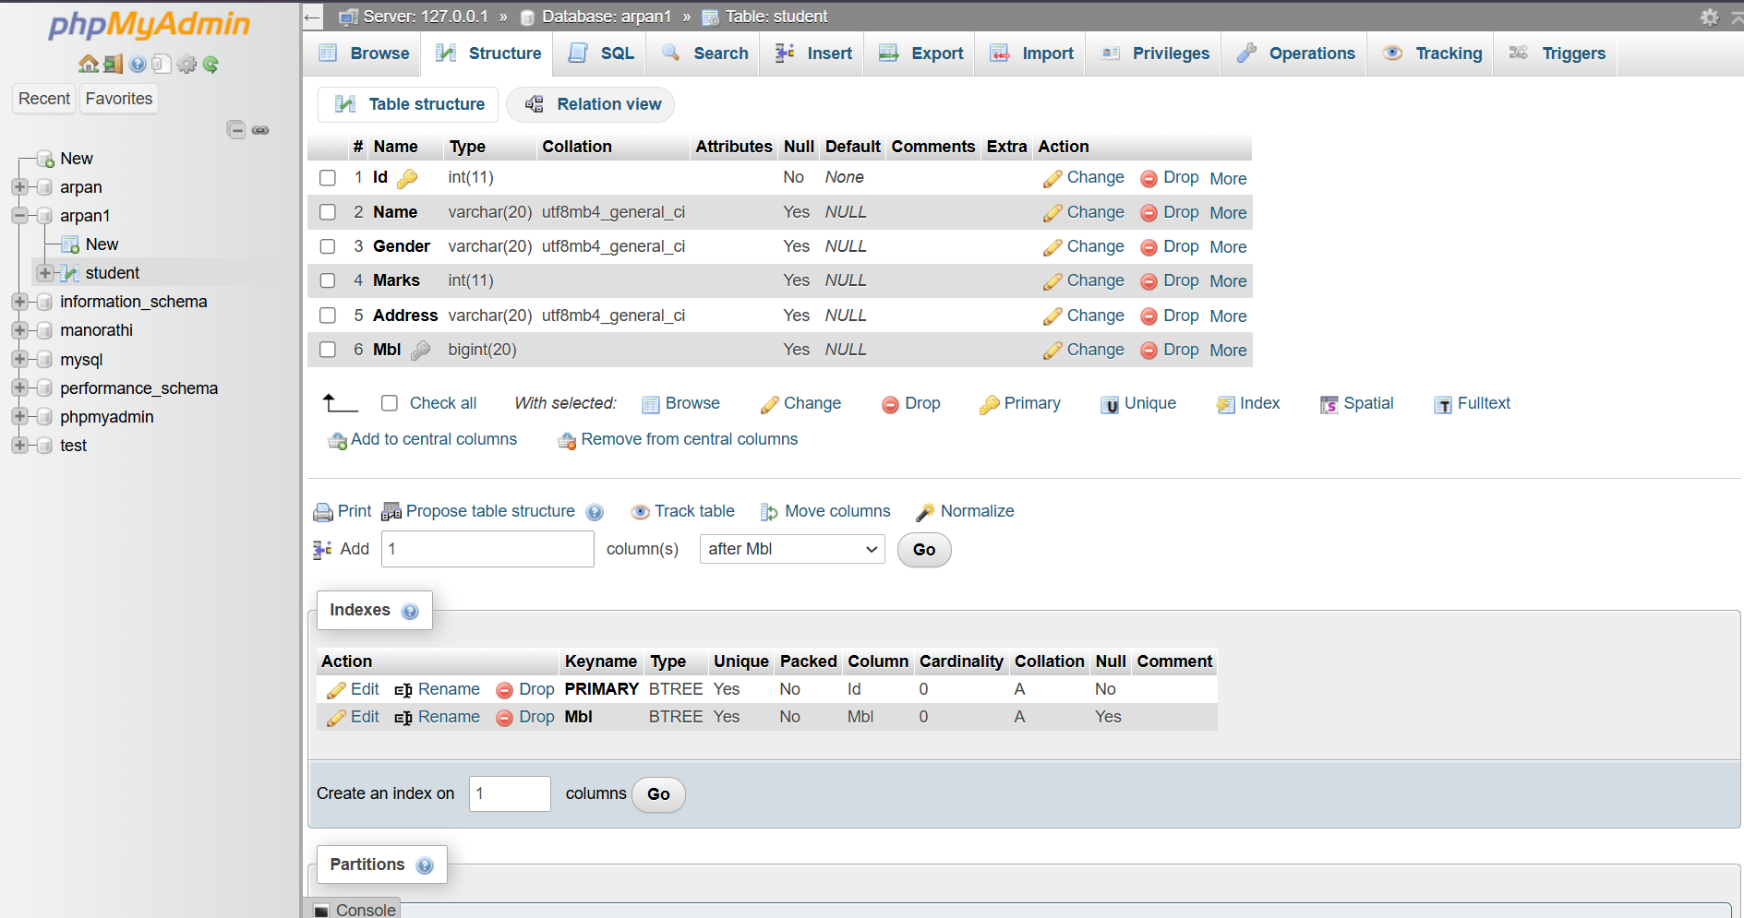

1. Insert all records.

Syntax:

Insert into student

values

(1,'Ram','Male',99,'Pokhara',9811223344),

(2,'Sujan','Male',89,'Kathmandu',9822334455),

(3,'Shyam','Male',60,'Kathmandu',9833445566),

(4,'Geeta','Female',88,'Lamjung',9844556677),

(5,'Rita','Female',48,'Tanahaun',9855667788),

(6,'Sujan','Male',90,'Pokhara',9866778899),

(7,'Shiva','Male',60,'Baglung',9877889900)

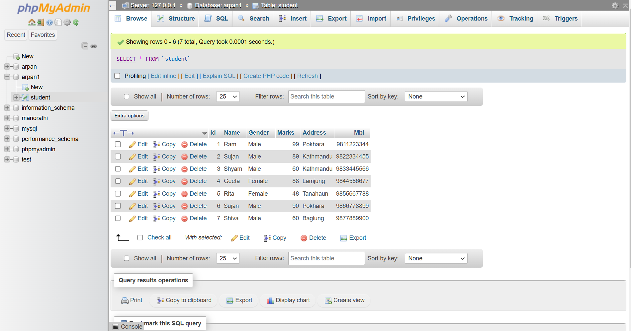

1. Increase the marks of student by 5% who scores 89 marks.

Syntax:

Update student

set marks= marks+marks*0.05 where marks=89;

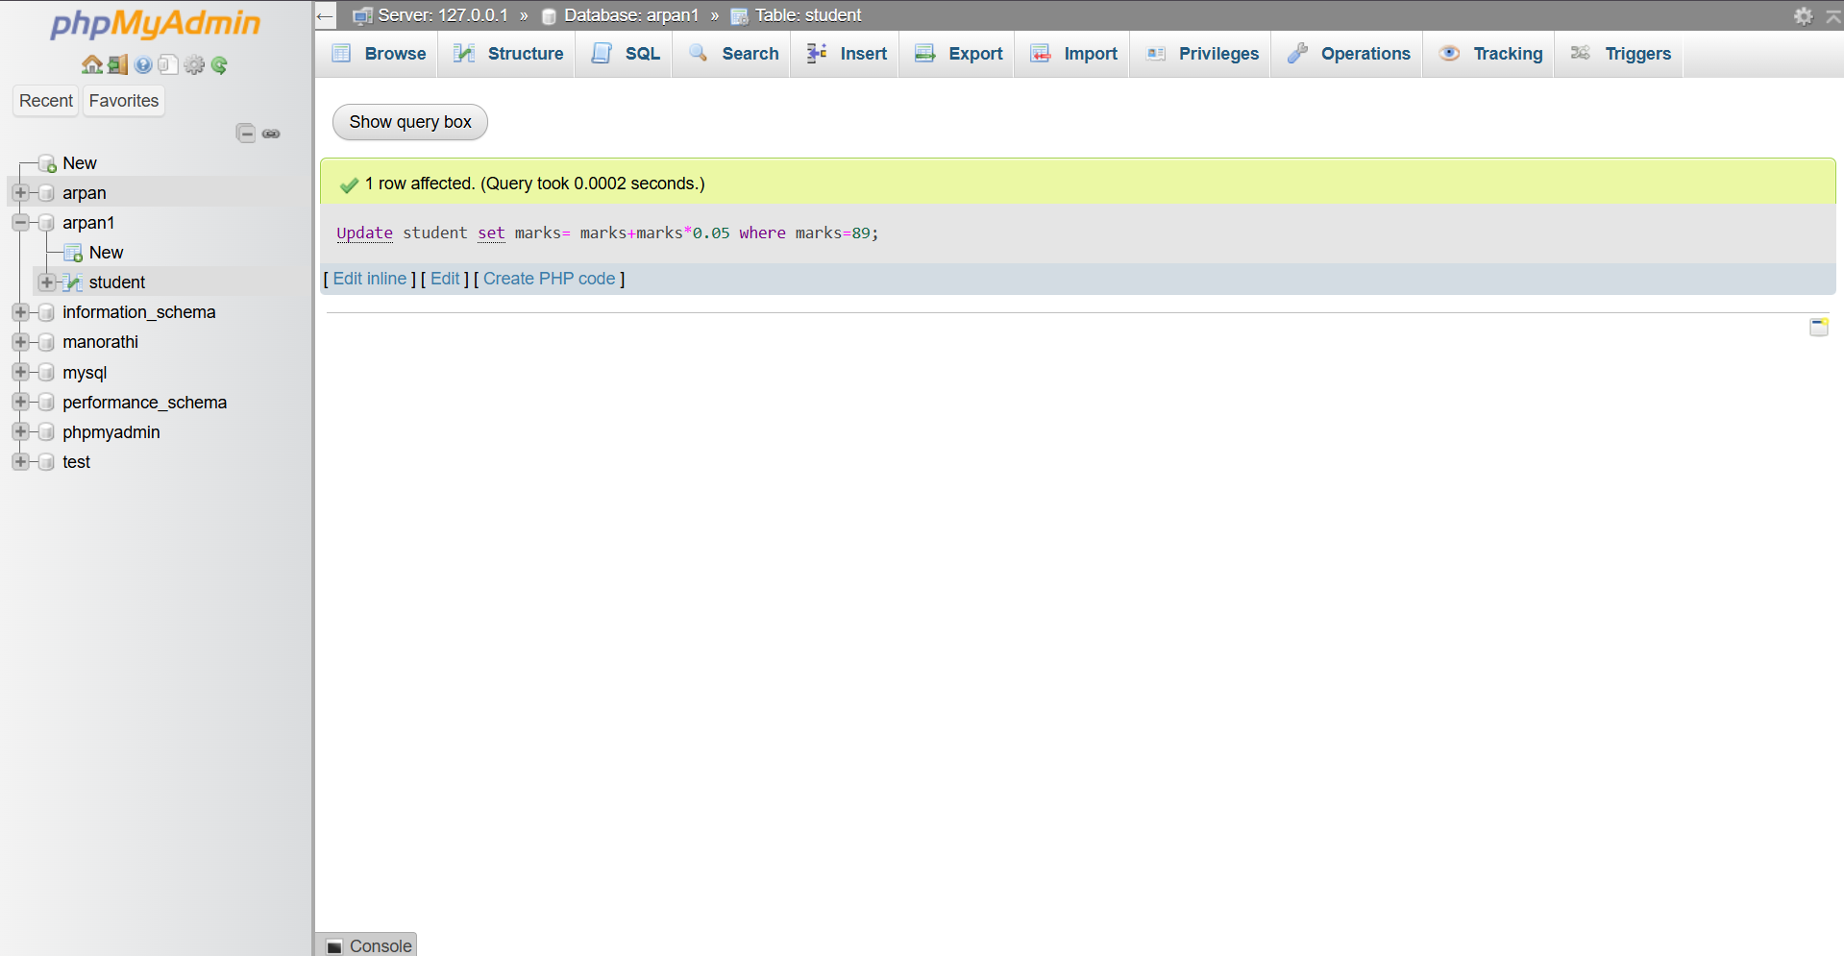

1. Decrease the marks of student by 5% who is from Kathmandu.

Syntax:

Update student

set marks=marks-marks*0.05

where address='Kathmandu';

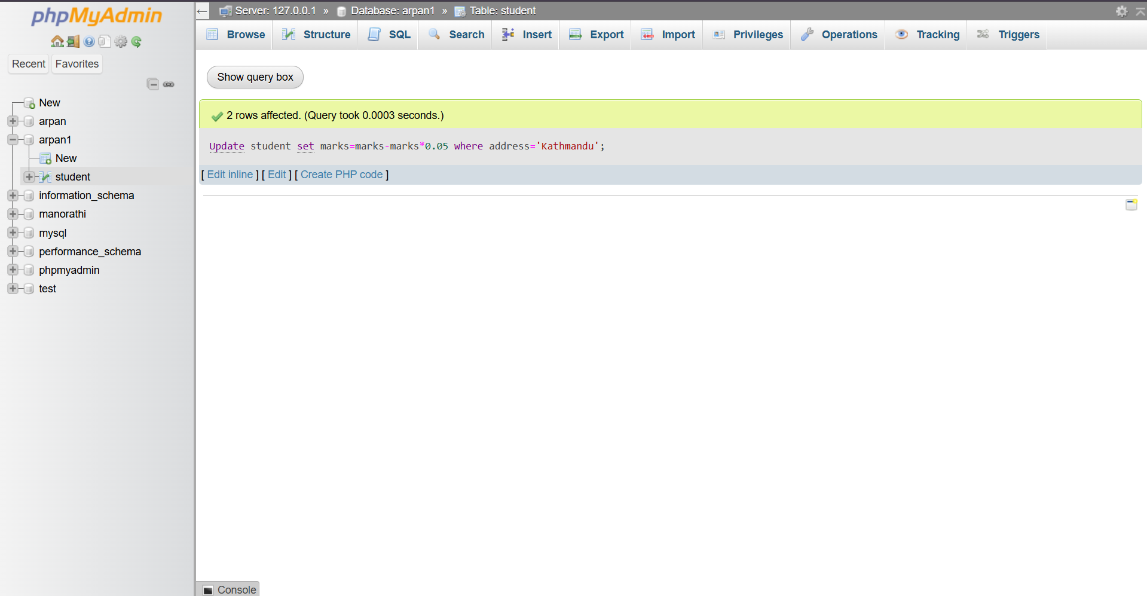

1. **Update the address of Ram or Rita to Janakpur.**

Syntax:

Update student

set address='Janakpur'

where name='Ram' or name='Rita';

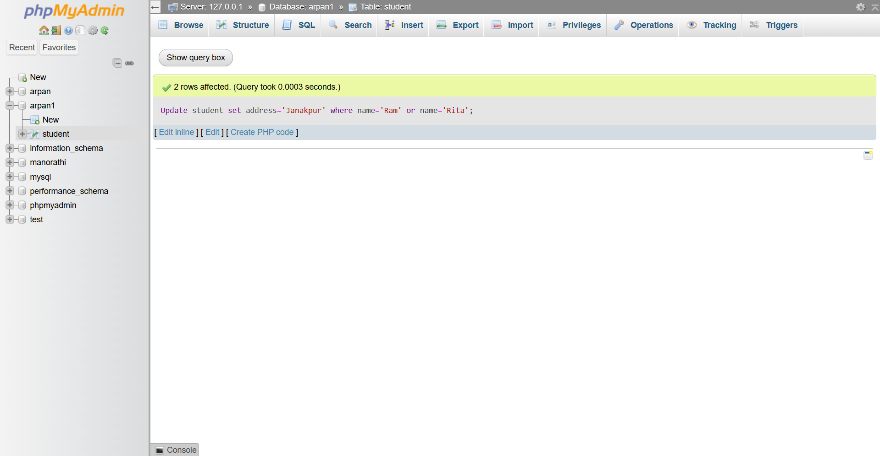

1. **Update the student marks to 68 whose last letter of name is m.**

Syntax:

Update student

set marks=68

where name like '%m';

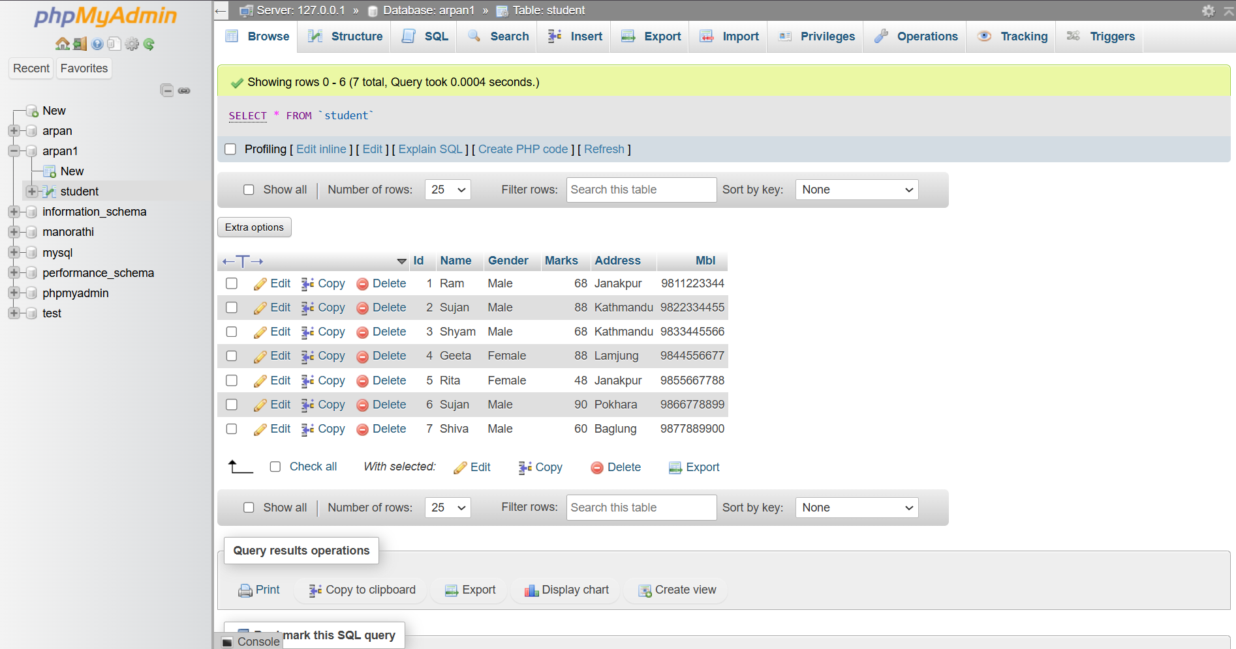

1. **Update the student’s name=arpan, gender=male, marks=99 and address=ktm whose id is 7.**

Syntax:

Update student

set name='Arpan', gender='Male', Marks=99, Address='Ktm'

where id=7;

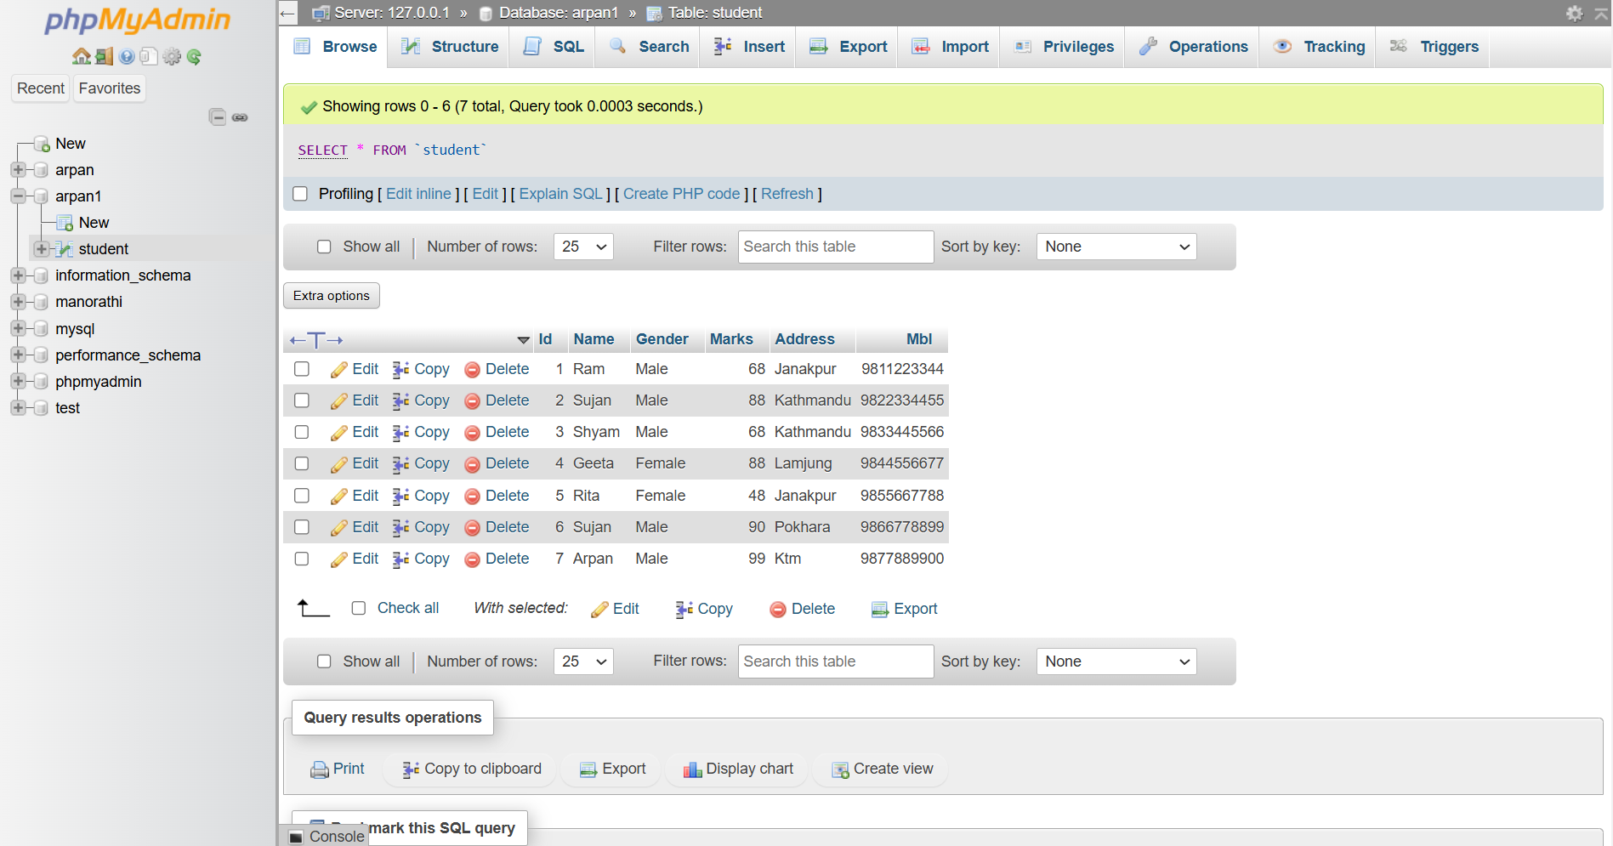

1. **Update address to Biratnagar and name Arpan who score 99 marks.**

Syntax:

Update student

set address='Biratnagar', name='Arpan'

where marks=99;

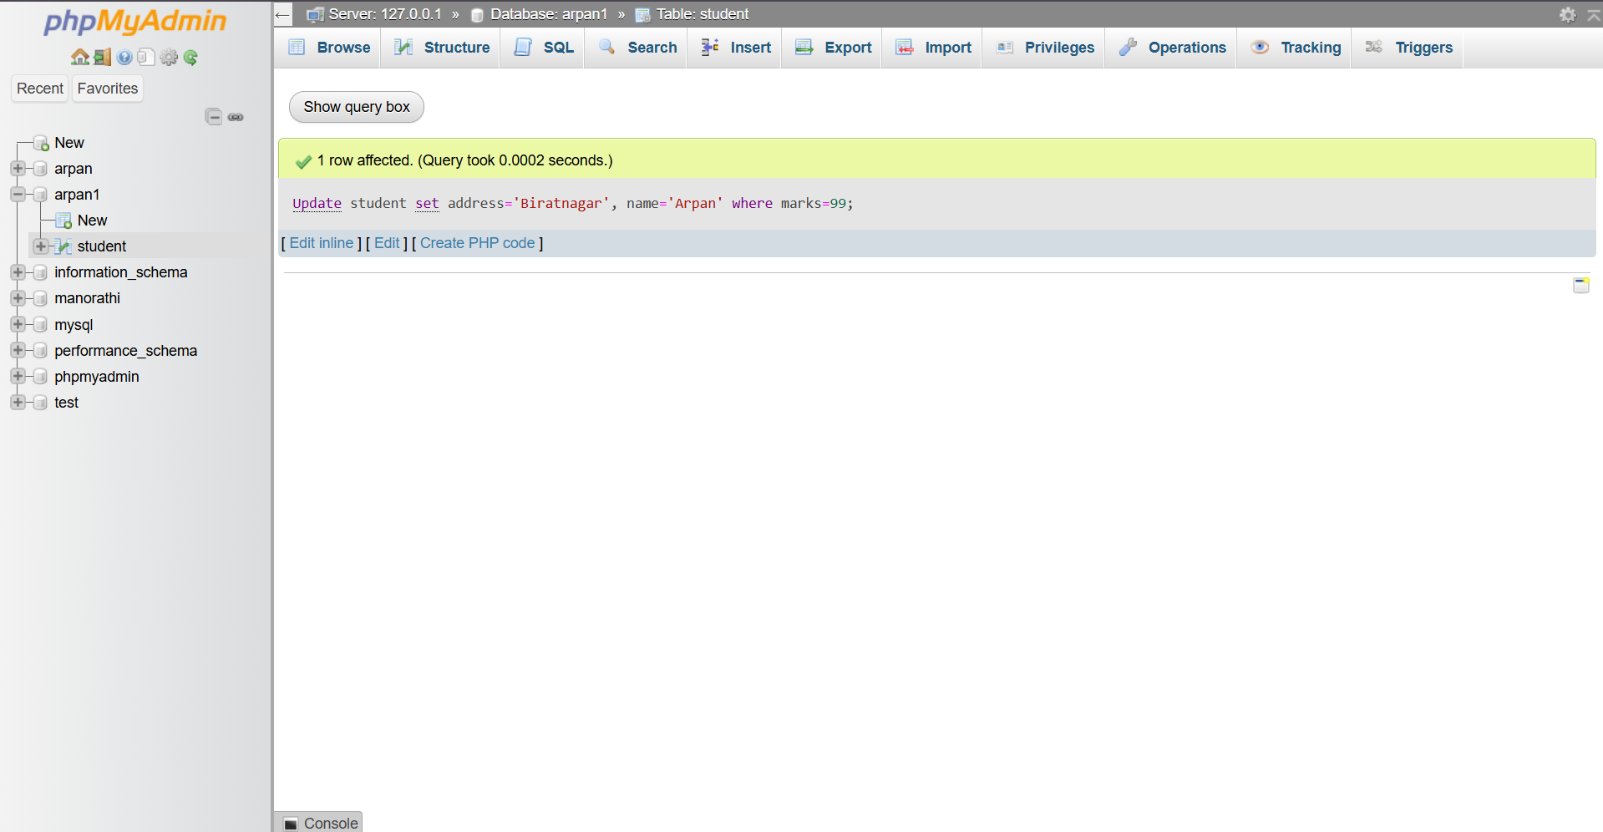

1. **Update the student to laxman and marks 85 who is from Kathmandu.**

Syntax:

Update student

set name='Laxman', marks=85

where address='Kathmandu';

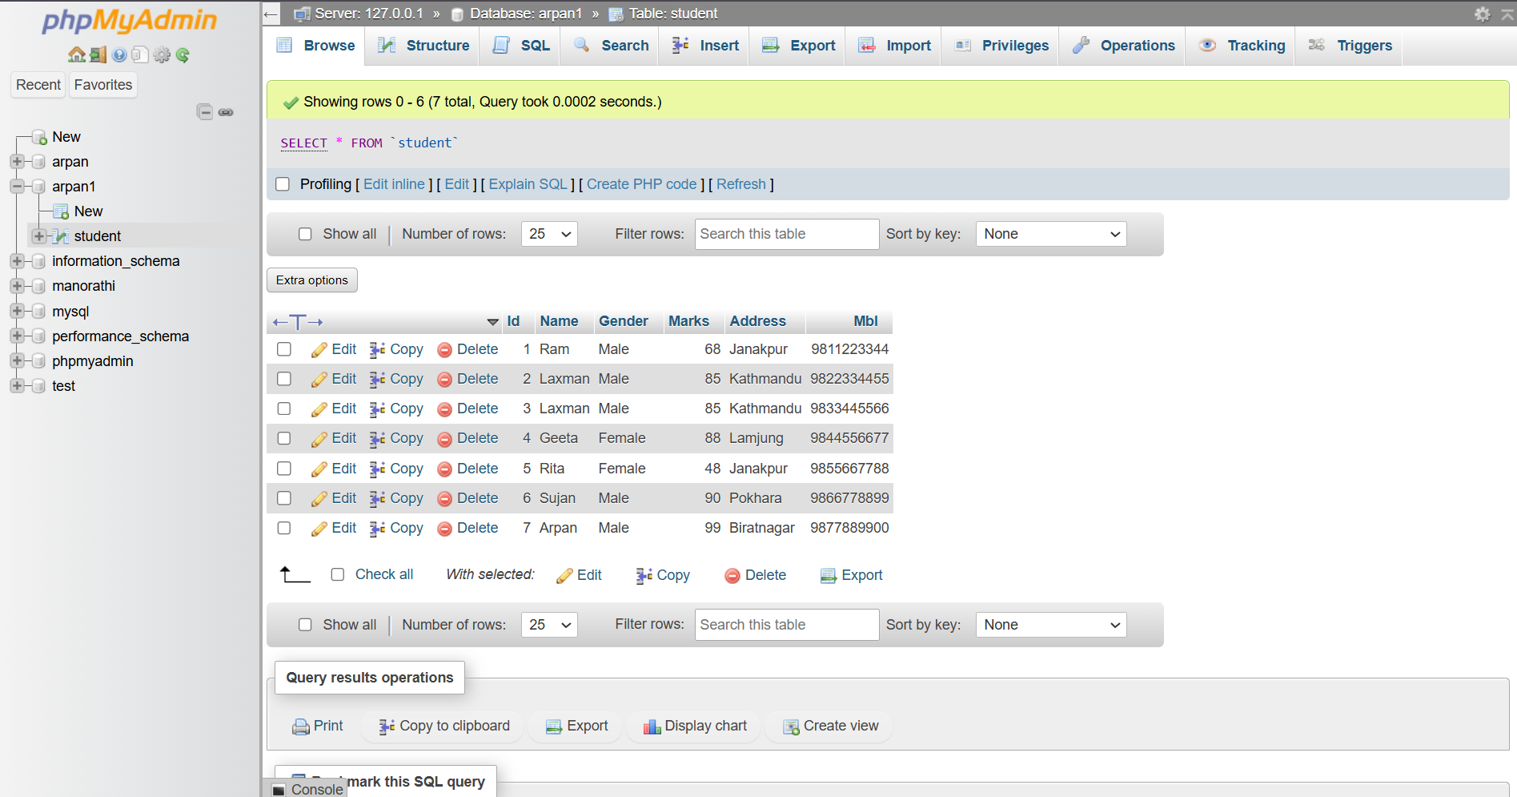

1. **Increase the marks of student who has 4 letters in their name by 10%.**

Syntax:

Update student

set marks=marks+marks*0.1

where length(name)=4;

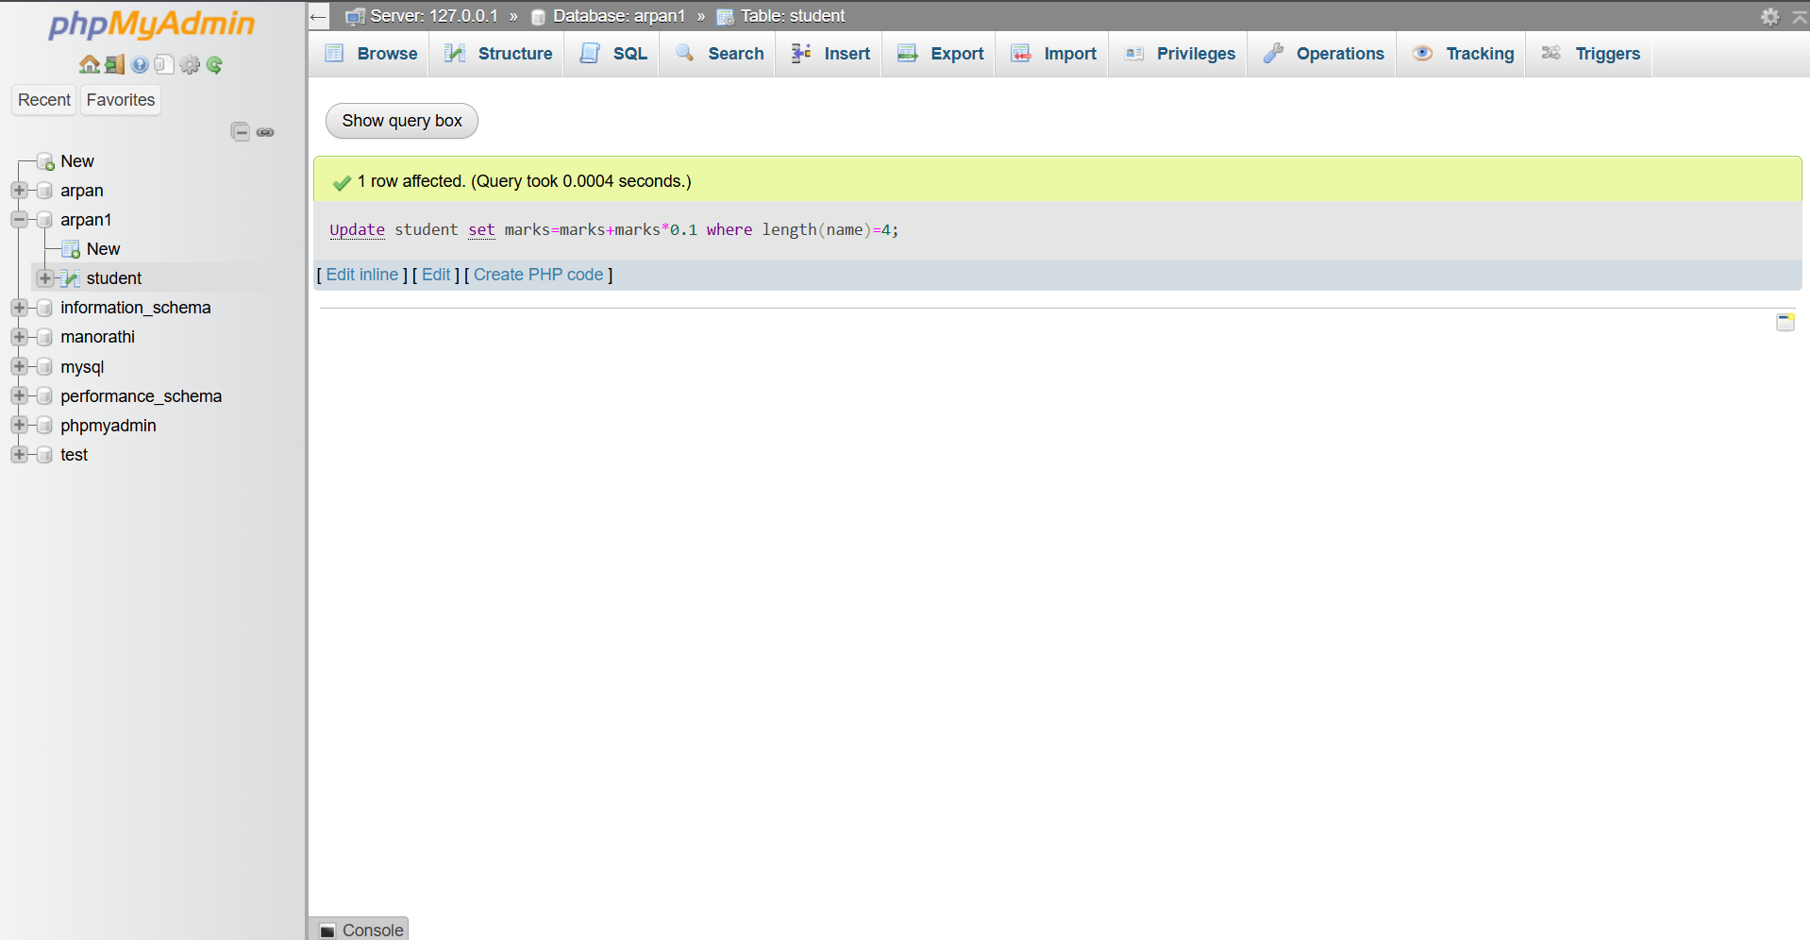

1. **Delete the records of an student who are from Pokhara and have score 90.**

Syntax:

Delete from student

where address='Pokhara' and marks=90;

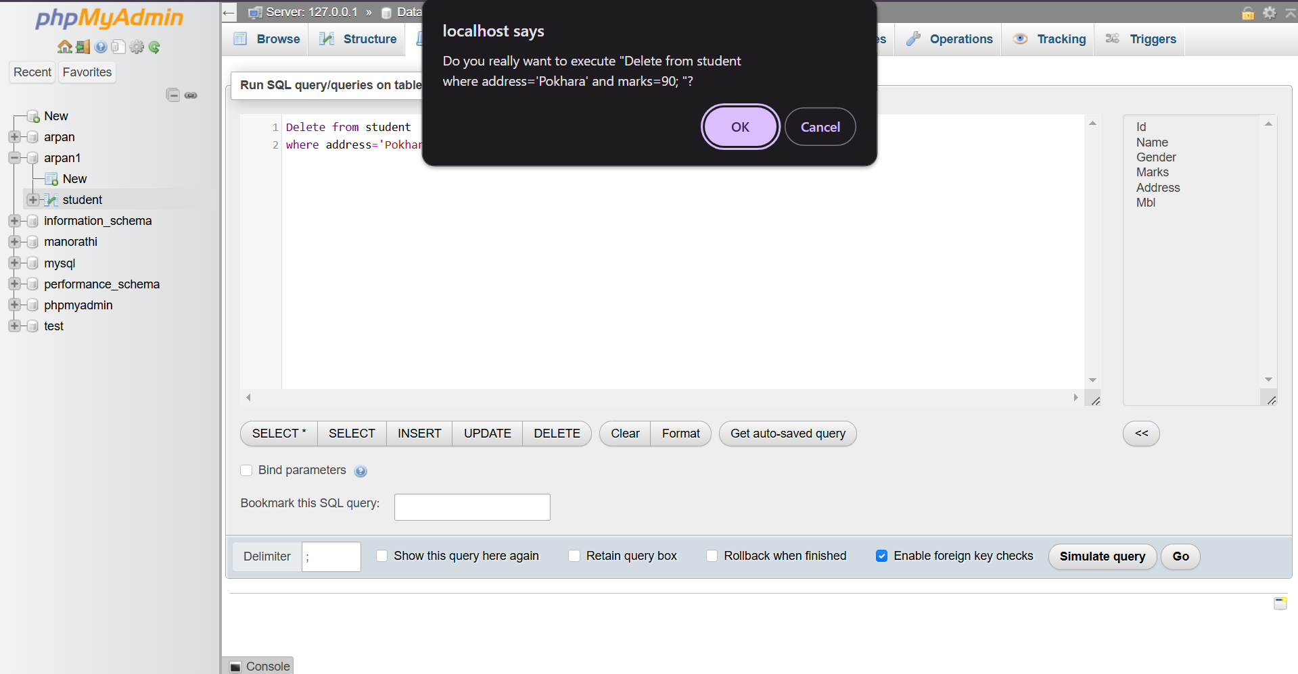

1. **Delete the record of an student whose phone is 9822334455 or marks=48.**

Syntax:

Delete from student

where Mbl=9822334455 or marks=48;

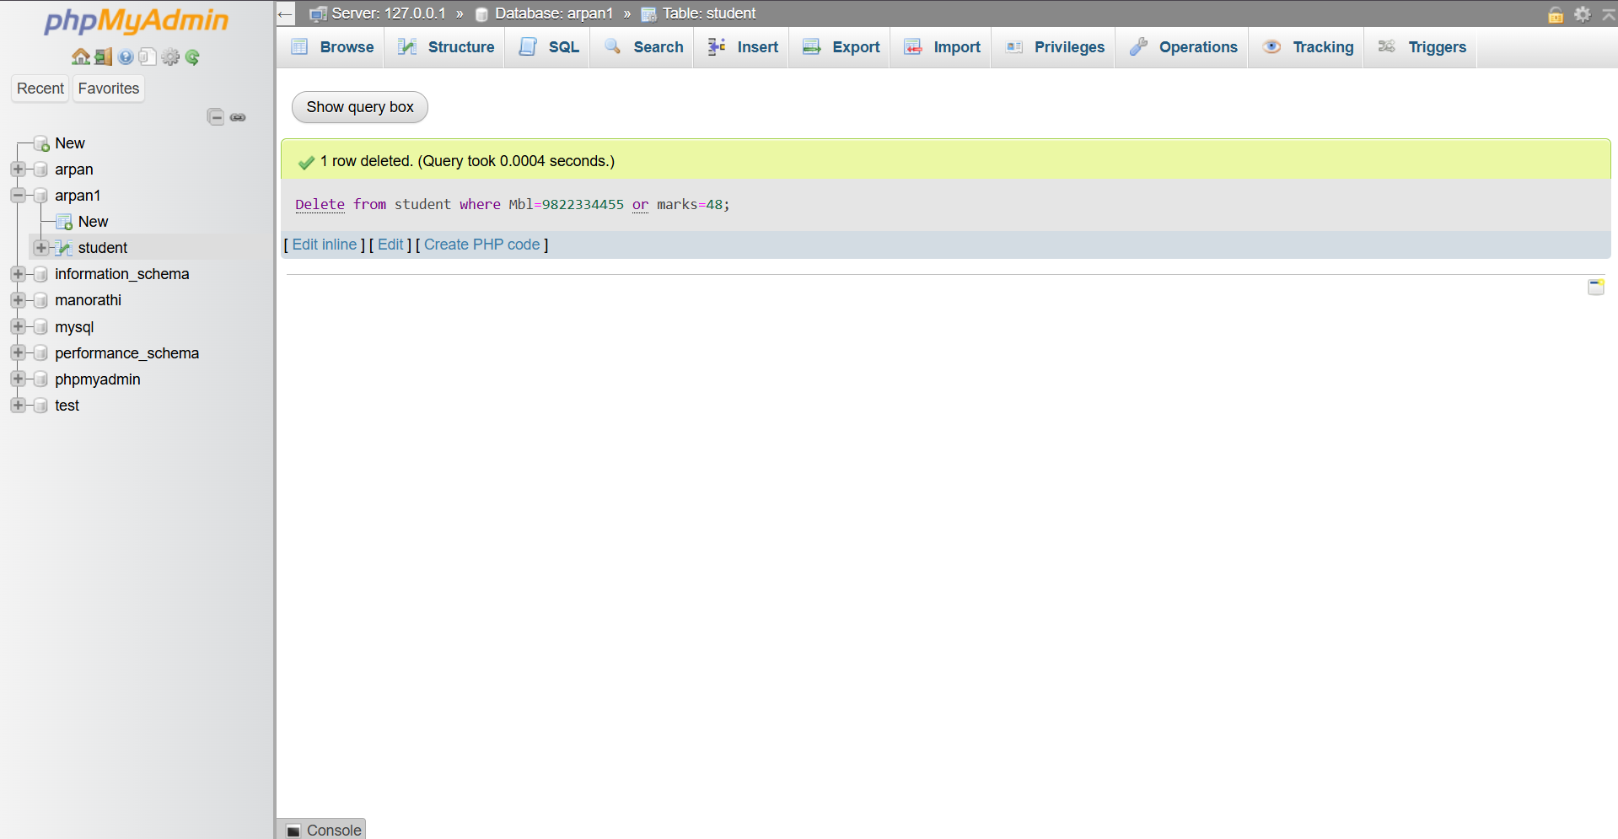

1. **Delete the records of the students whose name initial is R.**

Syntax:

Delete from student

where name like 'R%';

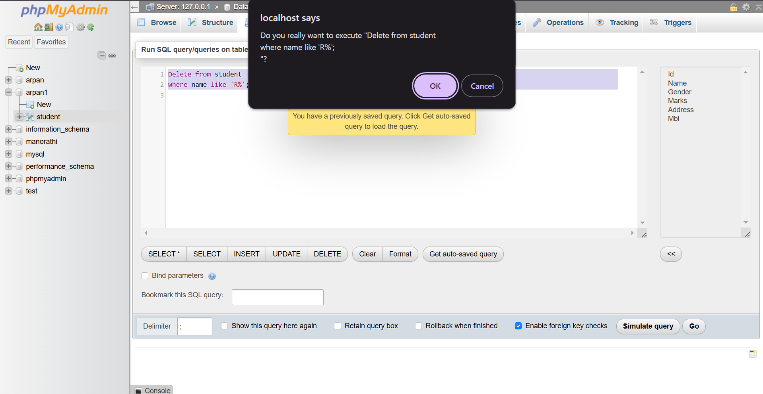

1. **Delete the records of students who is not from Kathmandu.**

Syntax:

Delete from student

where address!='Kathmandu';

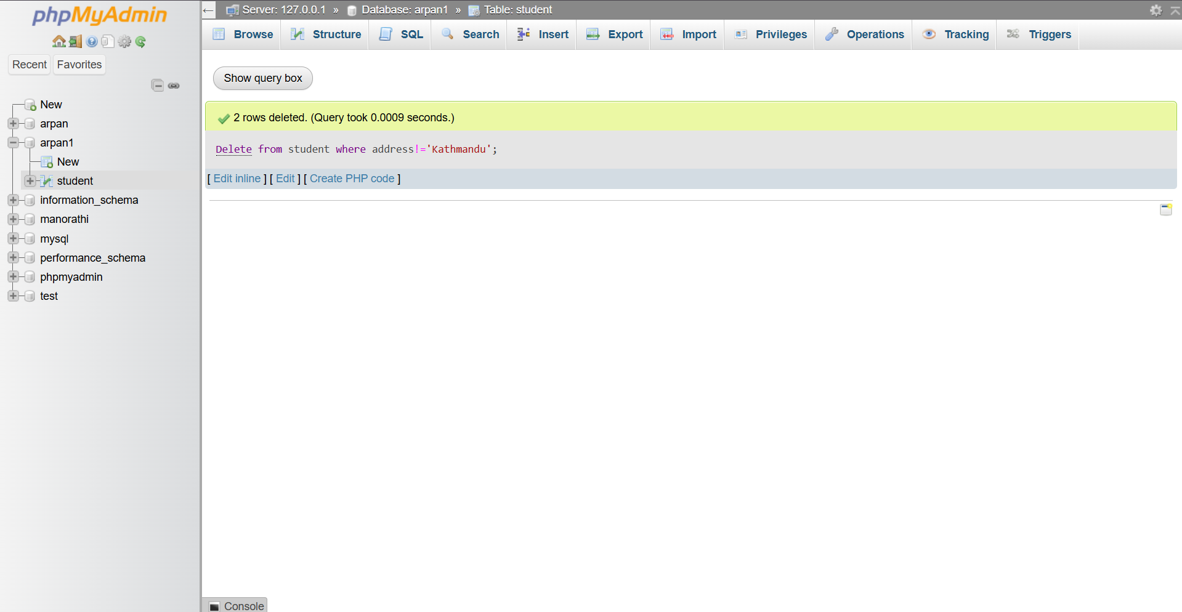

1. **.Create new table marks with column mid, DBMS, NM, Java marks. Insert some data and update the std table with marks where marks=sum of DBMS, NM, Java. Update arpan set total marks=(select sum (DBMS+NM+Java) from marks where arpan.id=marks.mid):**

Syntax:

CREATE TABLE marks

( mid INT PRIMARY KEY,

DBMS INT,

NM INT,

Java INT);

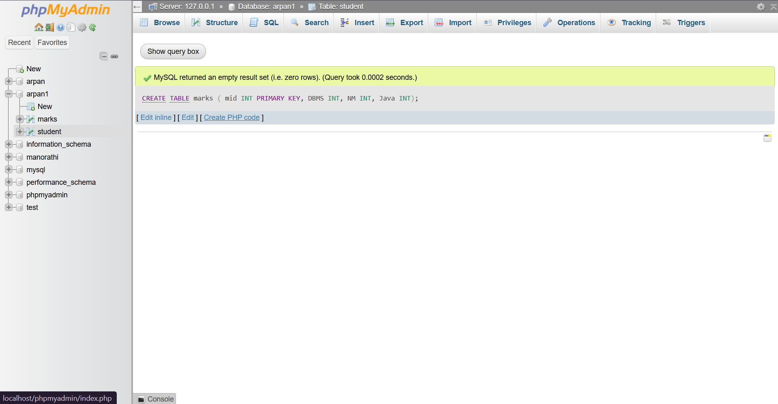

INSERT INTO marks

VALUES

(1, 85, 90, 88),

(2, 78, 82, 80),

(3, 92, 95, 93);

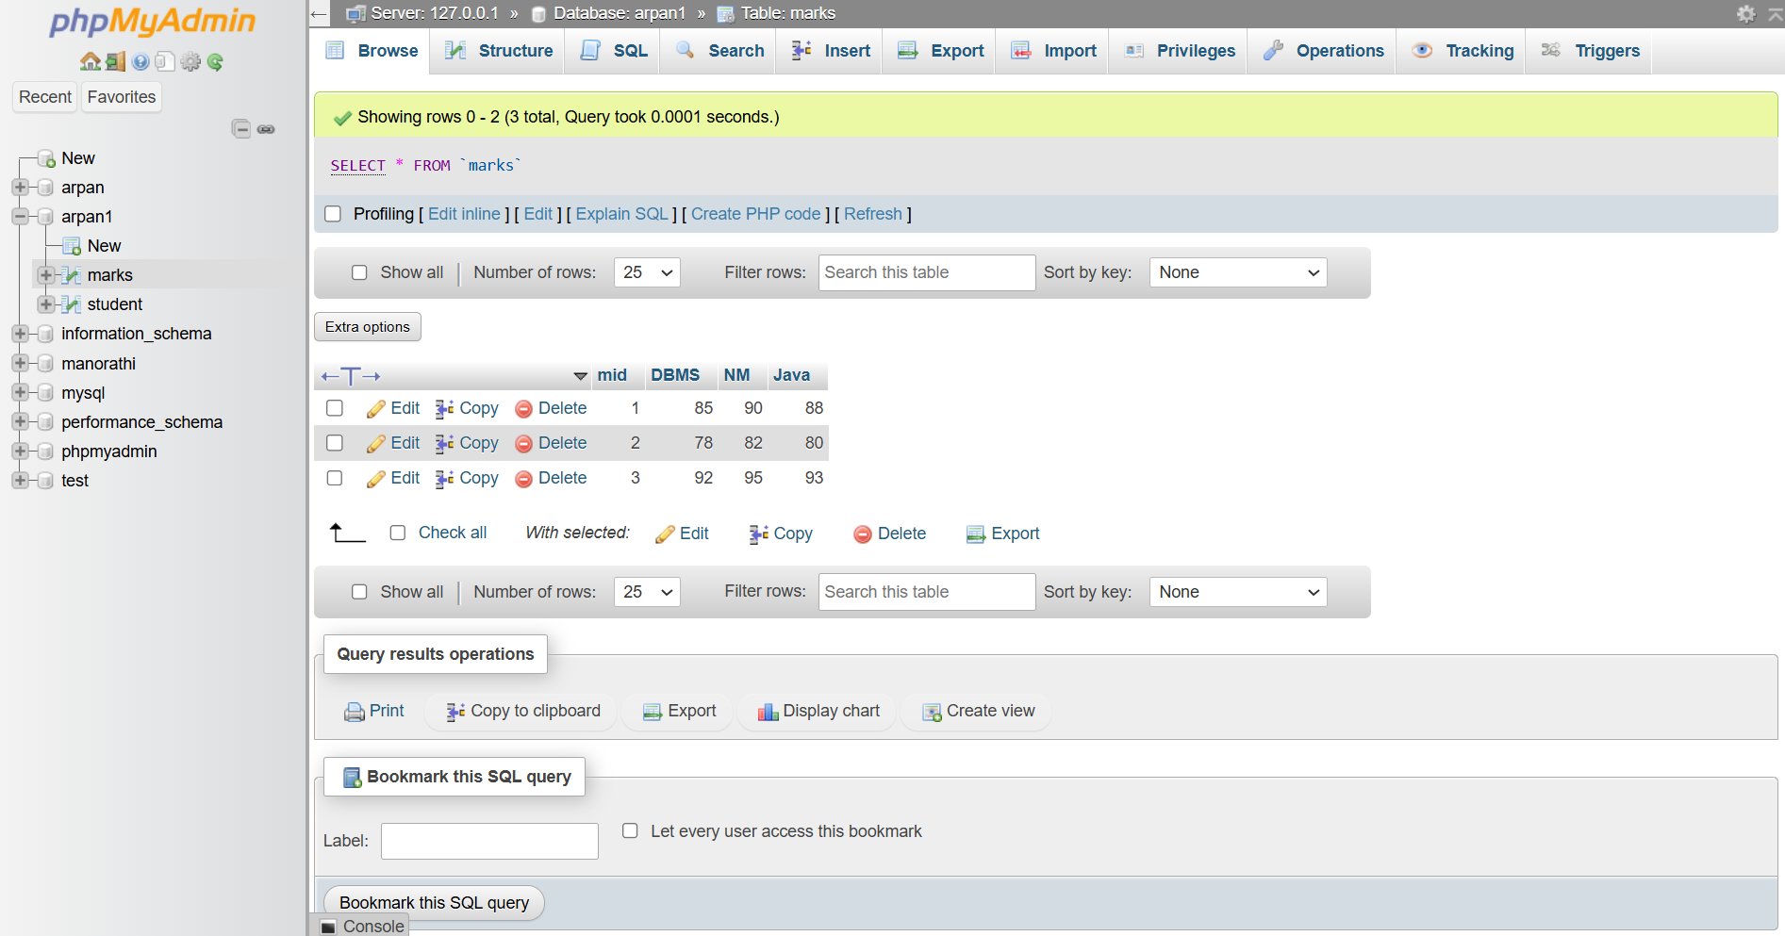

CREATE TABLE arpan

(id INT PRIMARY KEY,

total_marks INT);

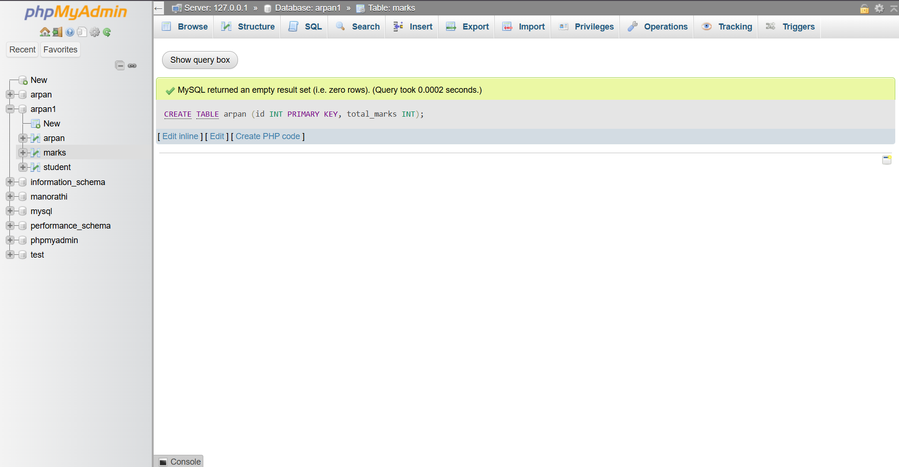

INSERT INTO arpan

VALUES

(1, 100),

(2, 100),

(3, 100);

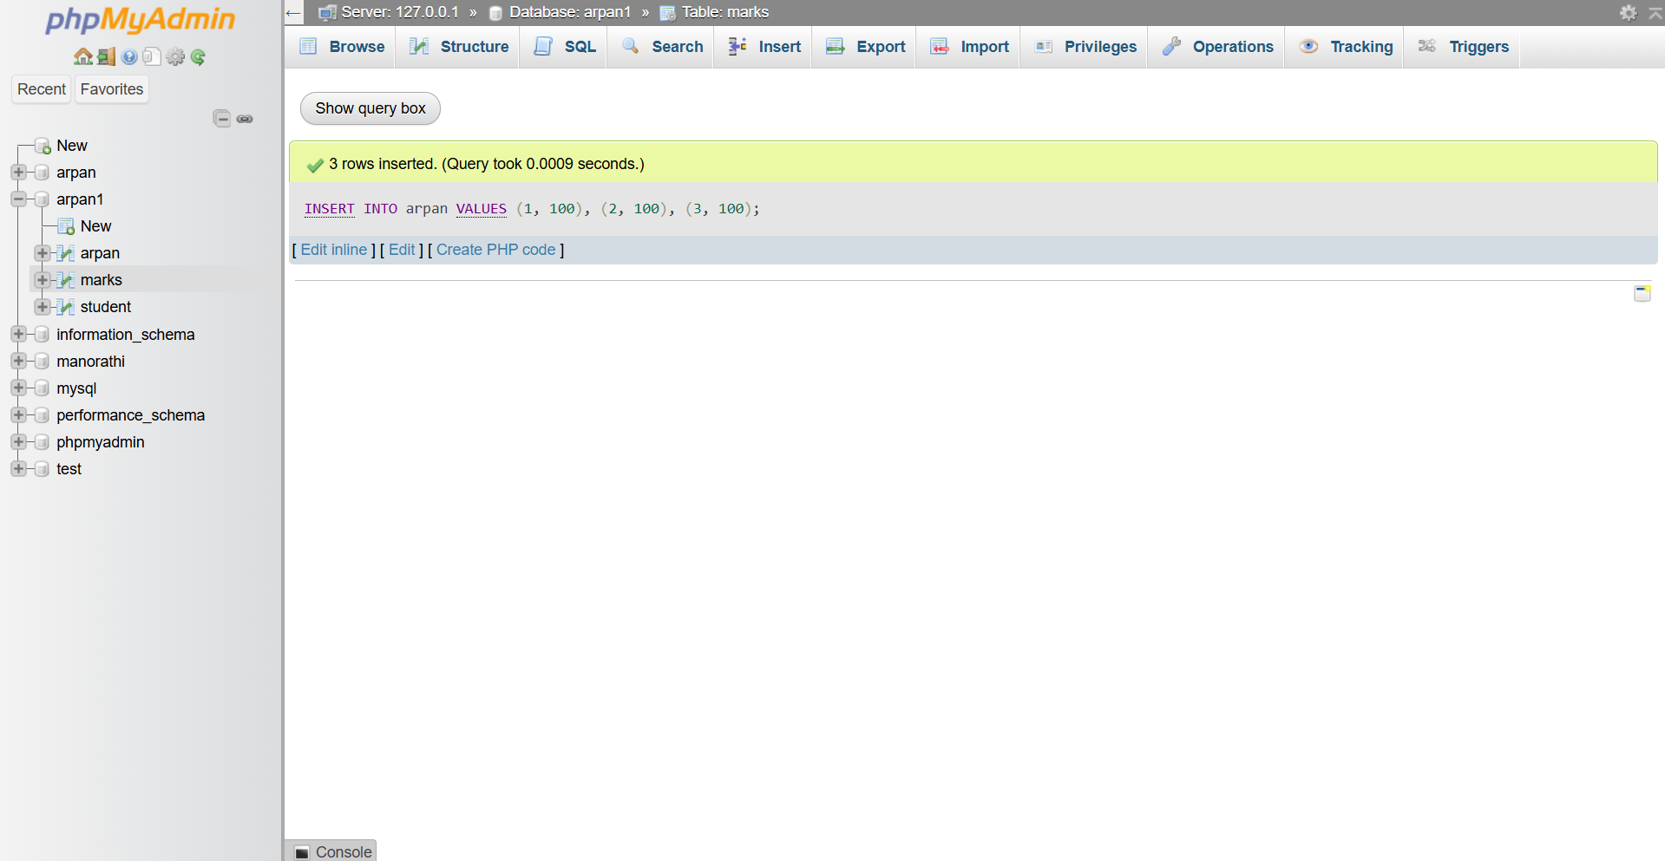

UPDATE arpan

SET total_marks = (SELECT SUM(DBMS + NM + Java) FROM marks

WHERE marks.mid = arpan.id);

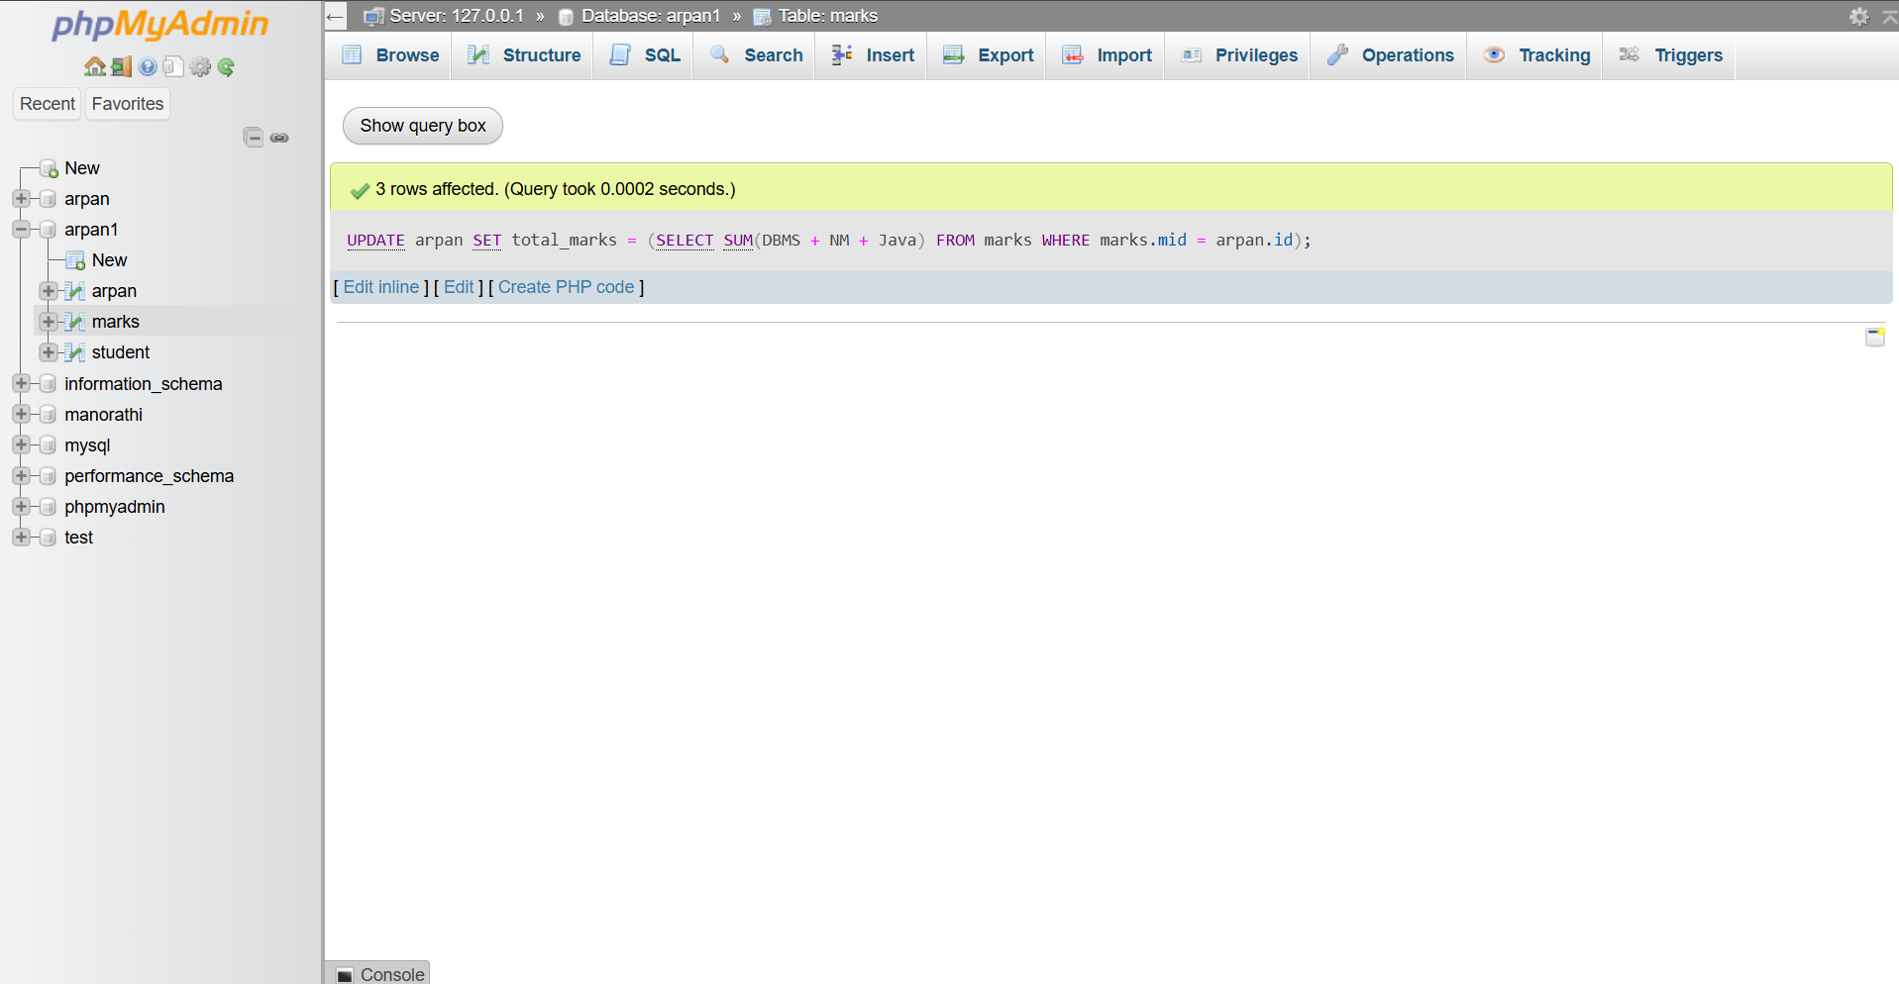

**Question 2:**

**Qno1.**

Create an employee table with attributes id (Primary key),  name, gender, salary (>2000), address, mbl (unique).

**Syntax:**

CREATE TABLE employee (

    id INT PRIMARY KEY AUTO_INCREMENT,

    name VARCHAR(50) NOT NULL,

    gender ENUM('Male', 'Female') NOT NULL,

    salary INT CHECK(salary>20000),

    address VARCHAR(50) NOT NULL,

    mbl VARCHAR(15) UNIQUE

);

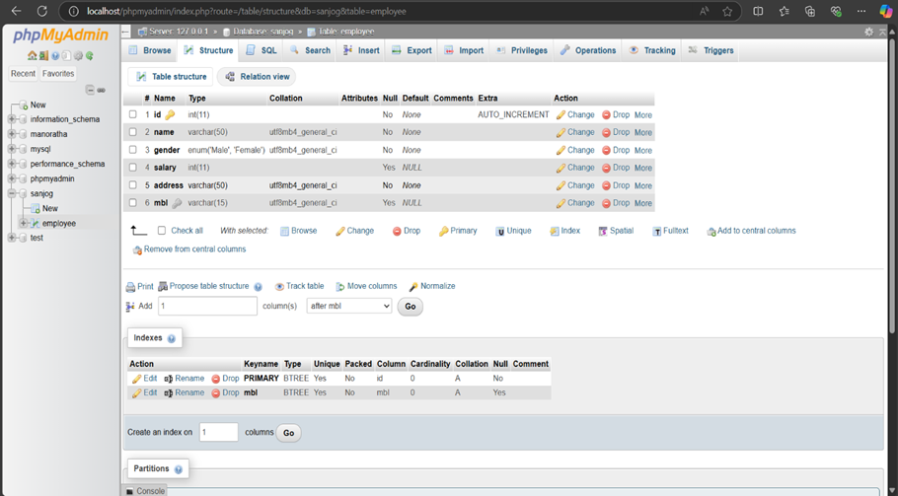

Qn no.2

Create table shop

**Syntax:**

INSERT INTO employee (name, gender, salary, address, mbl) VALUES

('Ram', 'Male', 21000, 'Ktm', '981112'),

('Ram', 'Female', 22000, 'Bkt', '981133'),

('Rita', 'Female', 21000, 'Bkt', '981144'),

('Sita', 'Female', 30000, 'Bkt', '981155'),

('Hari', 'Male', 35000, 'Pkr', '981166'),

('Shyam', 'Male', 35000, 'Chit', '981177'),

('Shyam', 'Female', 40000, 'Chit', '981188'),

('Krishna', 'Male', 40000, 'Pkr', '981199'),

('Radha', 'Female', 45000, 'Bkt', '982200'),

('Kamal', 'Male', 40000, 'Ktm', '982211');

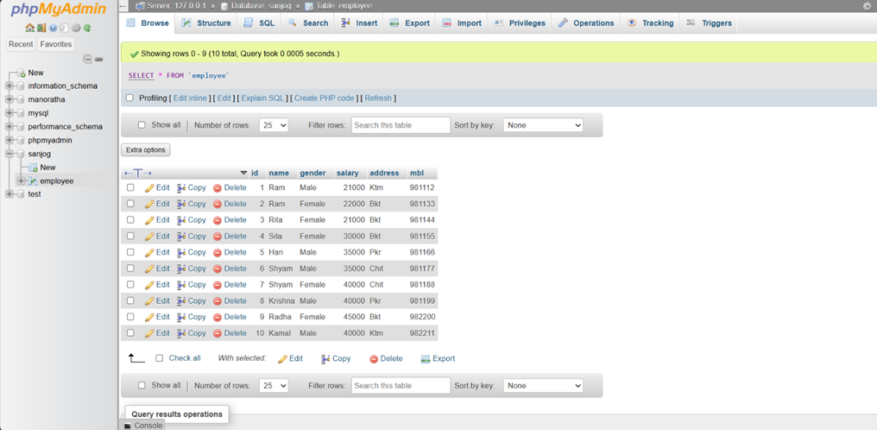

**Qn no .3**

Display distinct name

**Syntax:**

SELECT DISTINCT Name FROM employee;

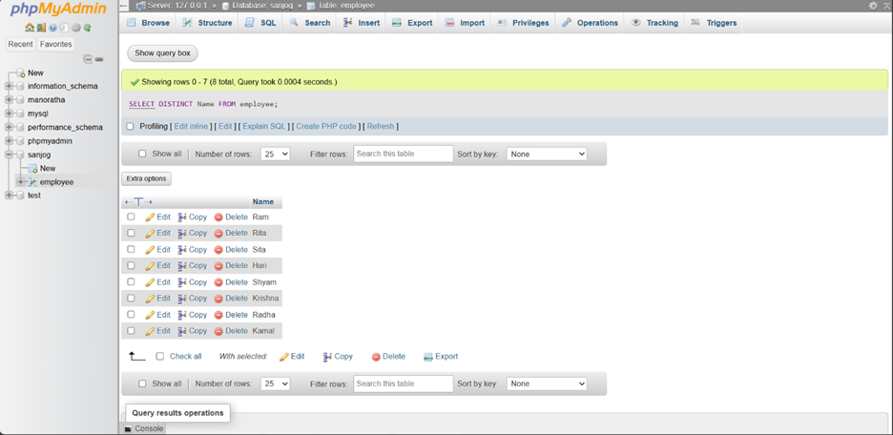

 Qn no.4.

Display distinct gender

**Syntax:**

SELECT DISTINCT gender FROM employee;

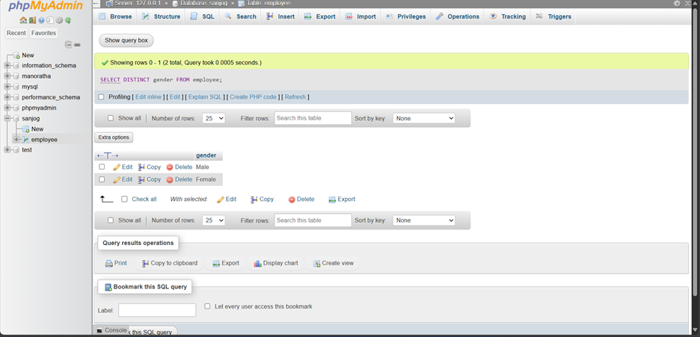

Qn no.5.

Update salary of  employee by 10% whose name is Ram

**Syntax:**

UPDATE employee

SET salary = salary * 1.1

WHERE name = 'Ram';

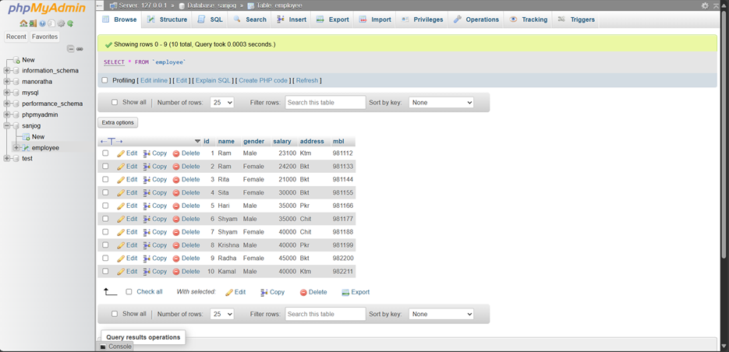

 Qn no.6

Update the address of an employee how are from ktm or pkt to bkt

**Syntax:**

UPDATE employee

SET address = 'Bkt'

WHERE address IN ('Ktm', 'Pkr');

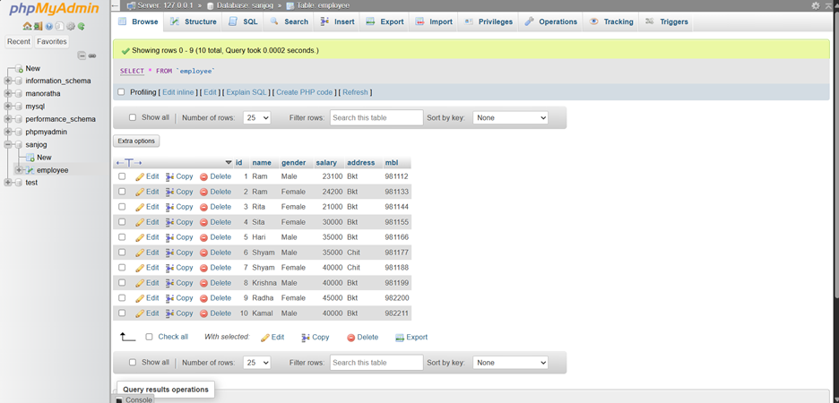

 Qn no7.

Update the gender of the employee whose name is kamal to m

**Syntax:**

UPDATE employee

SET gender = 'M'

WHERE name = 'Kamal';

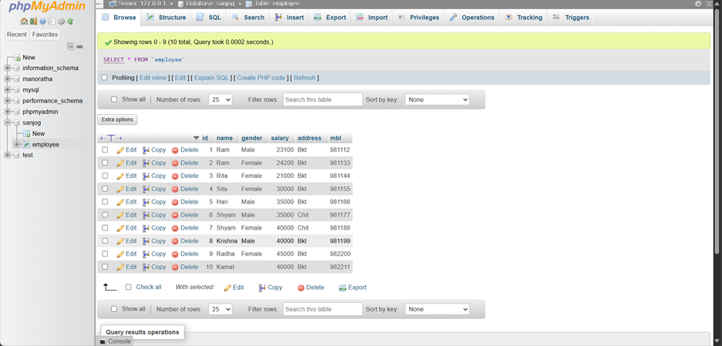

Qn no.8.

Update the address to Pkr whose address is Bkt and name starts from H

**Syntax:**

UPDATE employee

SET address = 'Pkr'

WHERE address = 'Bkt' AND name LIKE 'H%'

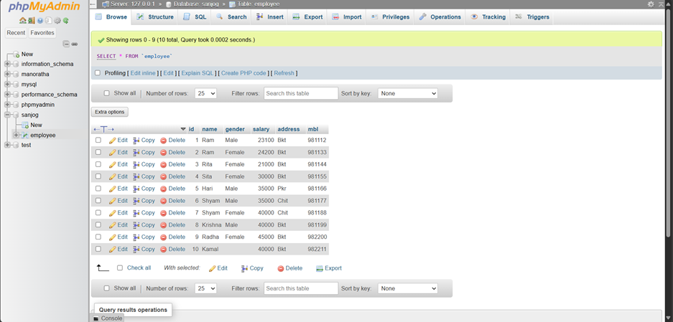

 Qn no 9.

Increase the salary of every employee by 10%

**Syntax:**

UPDATE employee

SET salary = salary * 1.1;

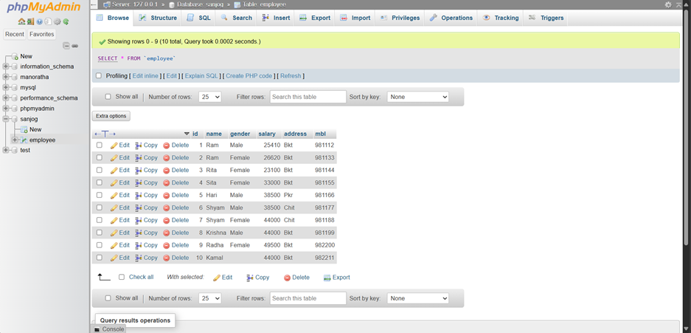

 Qn no. 10

Update the salary of employee by 20% who is from cht

**Syntax:**

UPDATE employee

SET salary = salary * 1.2

WHERE address = 'Cht';

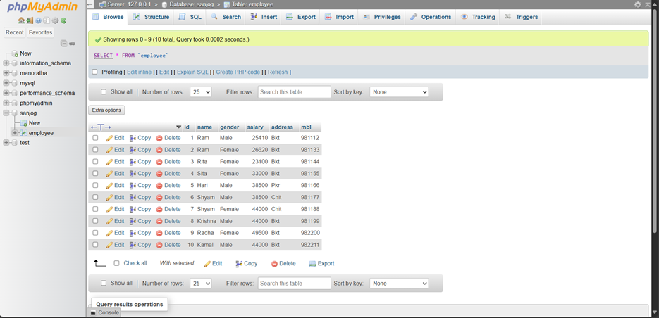

Qn no. 11.

Update the name to Radhe gender=male and salary=28000 who is from cht

**Syntax:**

UPDATE employee

SET name = 'Radhe', gender = 'Male', salary = 28000

WHERE address = 'Cht';

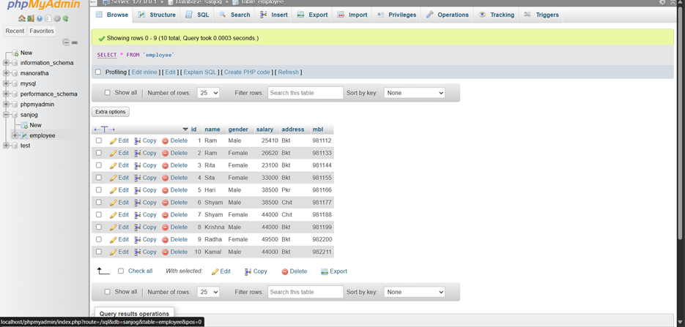

Qn. 12. Update the salary of the employee by 20% whose initial is s.

**Syntax:**

UPDATE employee

SET salary = salary * 1.2

WHERE name LIKE 'S%';

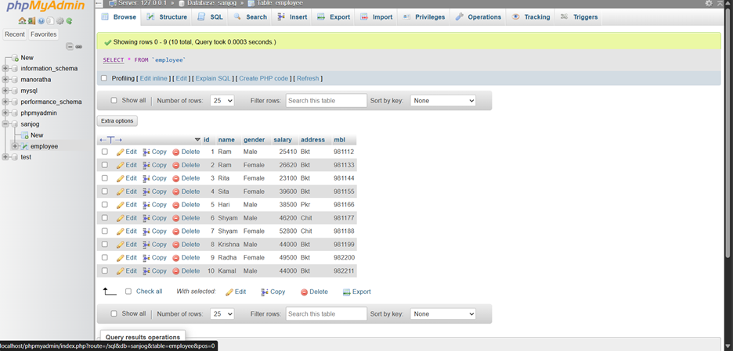

Qn no. 13. **Update address and mobile to "Bkt" and "1234" whose last ID is 4**

**Syntax:**

UPDATE employee

SET address = 'Bkt', mbl = '1234'

WHERE id = 1;

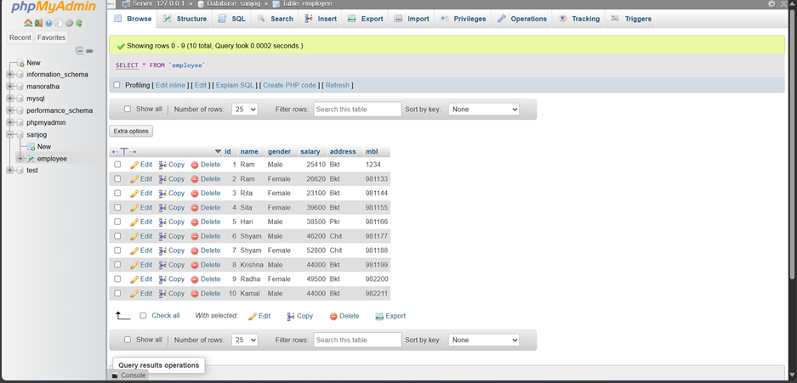

Qn no. 14. Delete the record of employee whose salary is less than 25000

**Syntax:**

DELETE FROM employee

WHERE salary < 25000;

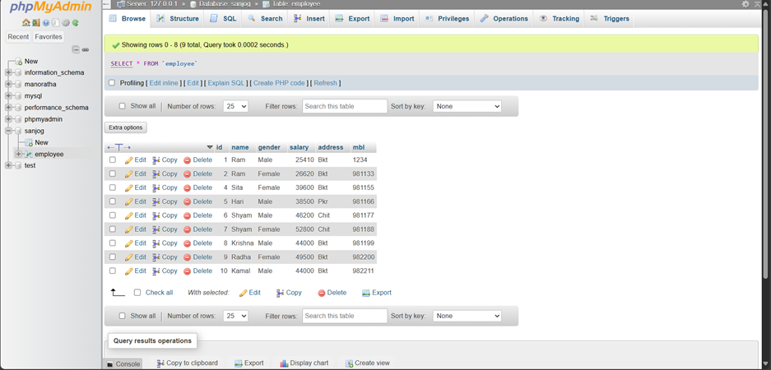

Qn no. 15. Delete the record of employee whose name is started form s

**Syntax:**

DELETE FROM employee

WHERE name LIKE 'S%';

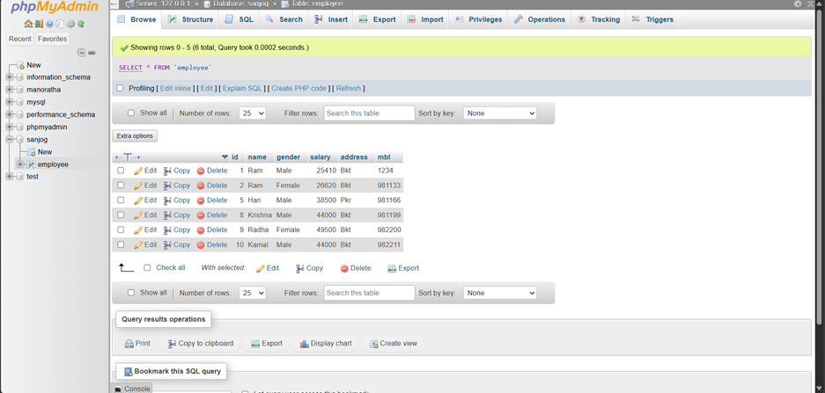

Qn no. 16. Delete the records of the employee whose name is mobile no is 981122

**Syntax:**

DELETE FROM employee

WHERE mbl = '981122';

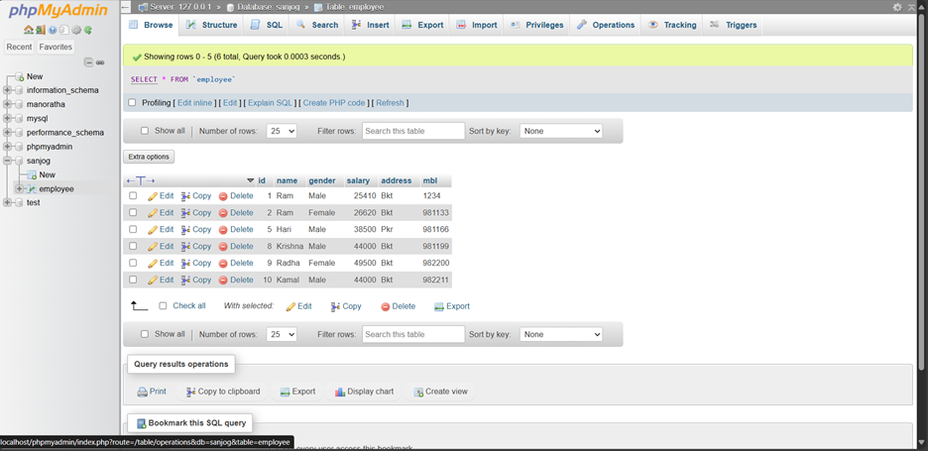

Qn no. 17. Delete the records of an employee whose name is krishna or gender= male or salary in between 30000 to 36000

**Syntax:**

DELETE FROM employee

WHERE name = 'Krishna'

   OR gender = 'Male'

   OR salary BETWEEN 30000 AND 36000;

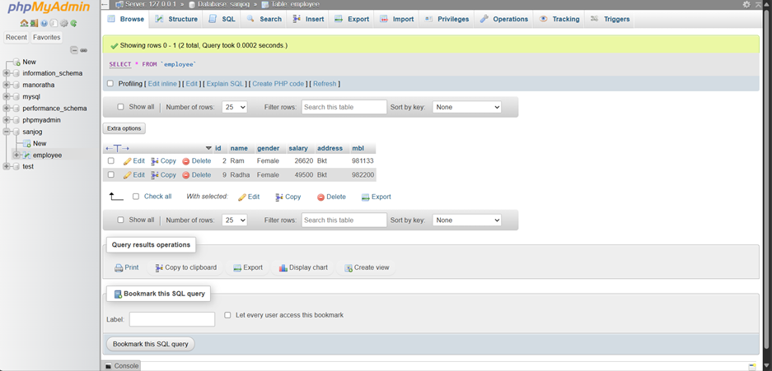

**CONCLUSION:**

Through this practical, we gained hands-on experience with essential Data Manipulation Language (DML) commands: **INSERT**, **UPDATE**, and **DELETE**. These commands are fundamental for managing data within a database, allowing us to add new records, modify existing ones, and remove unnecessary or erroneous data efficiently.

By understanding the syntax, functionality, and proper use of these commands, we reinforced the importance of maintaining data accuracy, consistency, and integrity. This practical also highlighted the need for careful use of conditions, such as the WHERE clause, to prevent unintended modifications or data loss. Mastery of DML commands is crucial for effective database management and real-world applications.